|  |
| --- |
| Name:H J K I Wijerama |
| Student Reference Number:10707417 |



|  |  |  |
| --- | --- | --- |
| Module Code: ISAD254SL | Module Name: Human Computer Interaction | |
| Coursework Title: In class activity | | |
| Deadline Date:  25 / 02 / 2021 | | Member of staff responsible for coursework:  Ms.pavithra Kankanamge |
| Programme: BSc(Hons)Software Engineering | | |
| Please note that University Academic Regulations are available under Rules and Regulations on the University website [www.plymouth.ac.uk/studenthandbook](http://www.plymouth.ac.uk/studenthandbook). | | |
| Group work: please list all names of all participants formally associated with this work and state whether the work was undertaken alone or as part of a team. Please note you may be required to identify individual responsibility for component parts.   * 10707417-H.J.K.Isindu Wijerama * 10707129-K.L.Dulani Anupama * 10707216-K.Charuka Heshan * 10713401-U.R.K.Ukwatta * 10707256 - N.N.D.G.Liyanage * 10707274 - P.Y.S.D.S.Manawadu   ***We confirm that we have read and understood the Plymouth University regulations relating to Assessment Offences and that we are aware of the possible penalties for any breach of these regulations. We confirm that this is the independent work of the group.***  Signed on behalf of the group:  nn  H.J.K.I. Wijerama | | |

|  |
| --- |
| Individual assignment: ***I confirm that I have read and understood the Plymouth University regulations relating to Assessment Offences and that I am aware of the possible penalties for any breach of these regulations. I confirm that this is my own independent work.***  Signed : |
| Use of translation software: failure to declare that translation software or a similar writing aid has been used will be treated as an assessment offence.  I *have used/not used translation software.  If used, please state name of software………………………………………………………………… |
| **Overall mark _____% Assessors Initials ______ Date_________** |



**ISAD254SL-Human Computer Interaction**

Group members :

* 10707417-H.J.K.Isindu Wijerama
* 10707129-K.L.Dulani Anupama
* 10707216-K.Charuka Heshan
* 10713401-U.R.K.Ukwatta
* 10707256 - N.N.D.G.Liyanage
* 10707274 - P.Y.S.D.S.Manawadu

**Predictability**

Predictive analytics is a way to predict future events based on past behavior. It’s a combination of statistics and [data mining](https://www.statisticshowto.com/data-mining/) .

* Nokia Vs. Apple

Unsurprising: Apple. Highlights function as-referenced. Contact functions as-guaranteed. Eccentric: Nokia. The majority of the occasions, it works. Some of the time it doesn't.

* Broadband Connectivity

You are in every case sure that you won't ever at any point get the guaranteed speed. [So you generally pick higher rates, pay more and basically anticipate the level of unpredictability] Additionally, on the clouded side of consistency is Sify. You realize the broadband association will go free, when it begins pouring (100% consistency here).

* Authentic/White collar laborers.

Unsurprising: If an auto specialist says '5 Minutes', you realize that it implies 30 minutes. [i.e. you foresee the margin]. Eccentric: Promise made by banks like ICICI on their administration, for example Nature of Service [a instance of over guarantee, under delivery?]. Once in a while it requires not many days for them to truly comprehend the circumstance (and at times the question is settled inside 30 minutes). Indeed it's as yet erratic.

* Chrome Vs. Others

Unsurprising: Chrome speed (directly from boot to autosuggestion) Unusual: Mozilla (nowadays).

* Bollywood

Shahrukh Khan is unsurprising. Aamir Khan isn't. Johny Walker was. Large B isn't. There is no example here. They all are saints in their own terms [the saying that goes in Bollywood is that "In the event that you are unsurprising, you are replaceable"].

* Dispatch Service

DHL is unsurprising (you can follow on constant premise). The vast majority of the nearby messenger organizations aren't. Advise us in the event that you address greater expense for consistency, or the majority of the occasions you wind up looking at the nearby ones?

* Installment Gateways (PGs)

The greater part of the web based business sites realize that installment entryways are unusual. So how have they dealt with adapt up? They have incorporated all conceivable PGs, to expand consistency.

* Power plants

including wind power installations, use predictive analytics to reduce unexpected equipment failures, reduce maintenance costs and improve power availability.

* Cybersecurity

is a growing concern. Real-time analytics examines network traffic to identify patterns that may indicate fraud, computer-software vulnerability or other threats.

**Synthesizability**

Assessing the effect of past actions and immediate vs. eventual honesty. Synthesizability refers to the user‟s ability to judge the effects of past operations on the present circumstances.

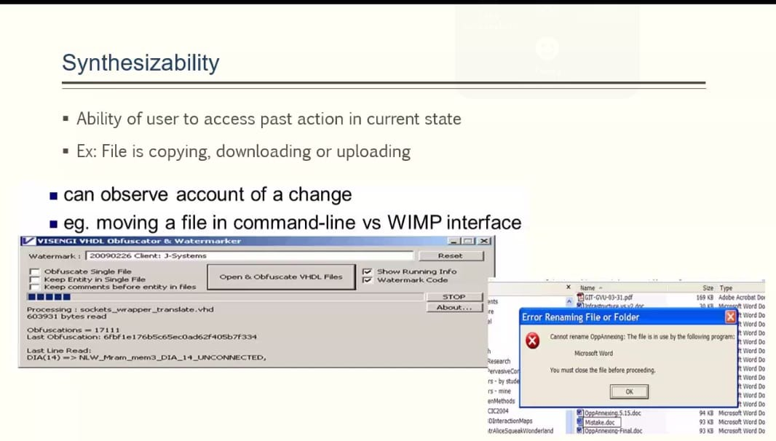

**Familiarity**

Commonality alludes to what condition the user‟s information and involvement with genuine world or PC based offices can be applied while interfacing with another framework. For example,

At the point when the word processor was at first presented, the comparability of word processor and typewriter were intentionally presented. The likeness between the word processor and a typewriter was imagined to assemble another innovation all the more immediately open for the individuals who had certain involvement in the typewriter.

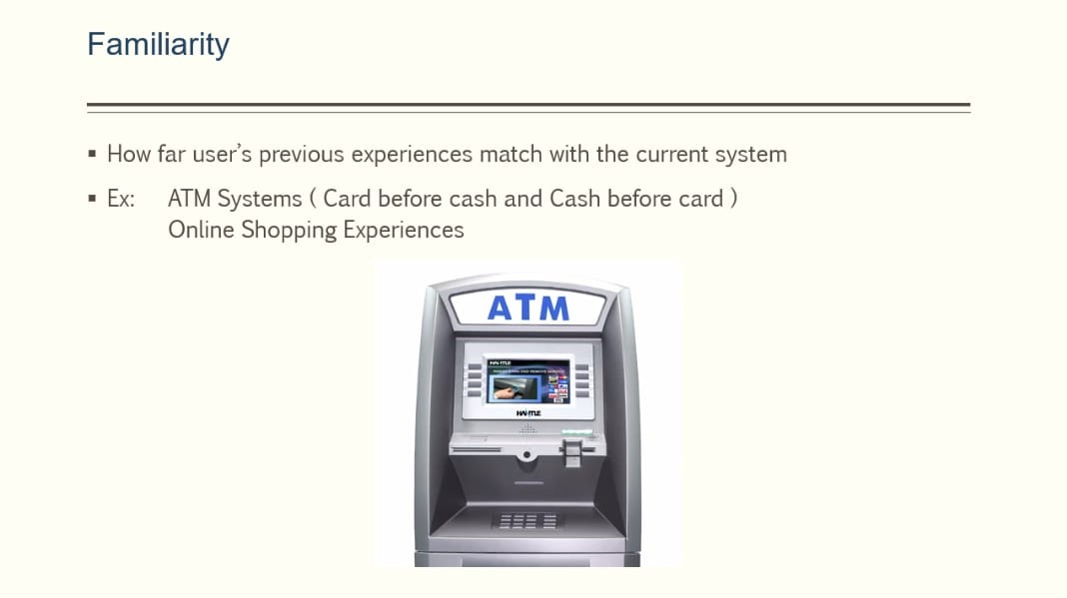

**Generalization**

Generalizability alludes to the help for the client to amplify the information on a specific collaboration inside and across application to other related circumstances. By and large, clients attempt to widen their insight into specific connection developments to related conditions. Speculation can be utilitarian to information, which supports to accomplish a specific objective or a objective that is some path related with the comparable activity acted in the site. This expands the generalizability of the site.

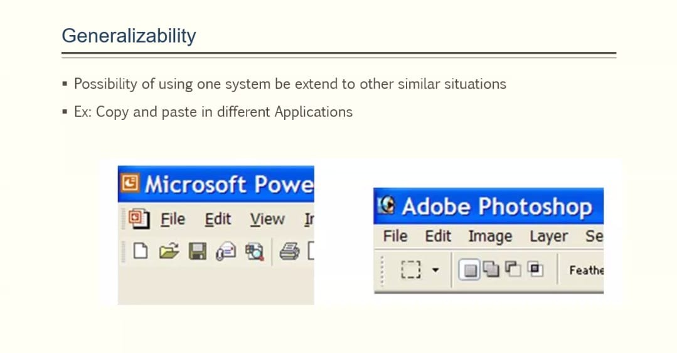

**Consistency**

You can most likely see presently how very much characterized plan elements lead to the different degrees of consistency. For instance:

consistency in naming, contracts, cooperation and so on Very much characterized plan elements truly imply that you know precisely where to go when you search a touch of code, where to compose a specific piece of the execution

